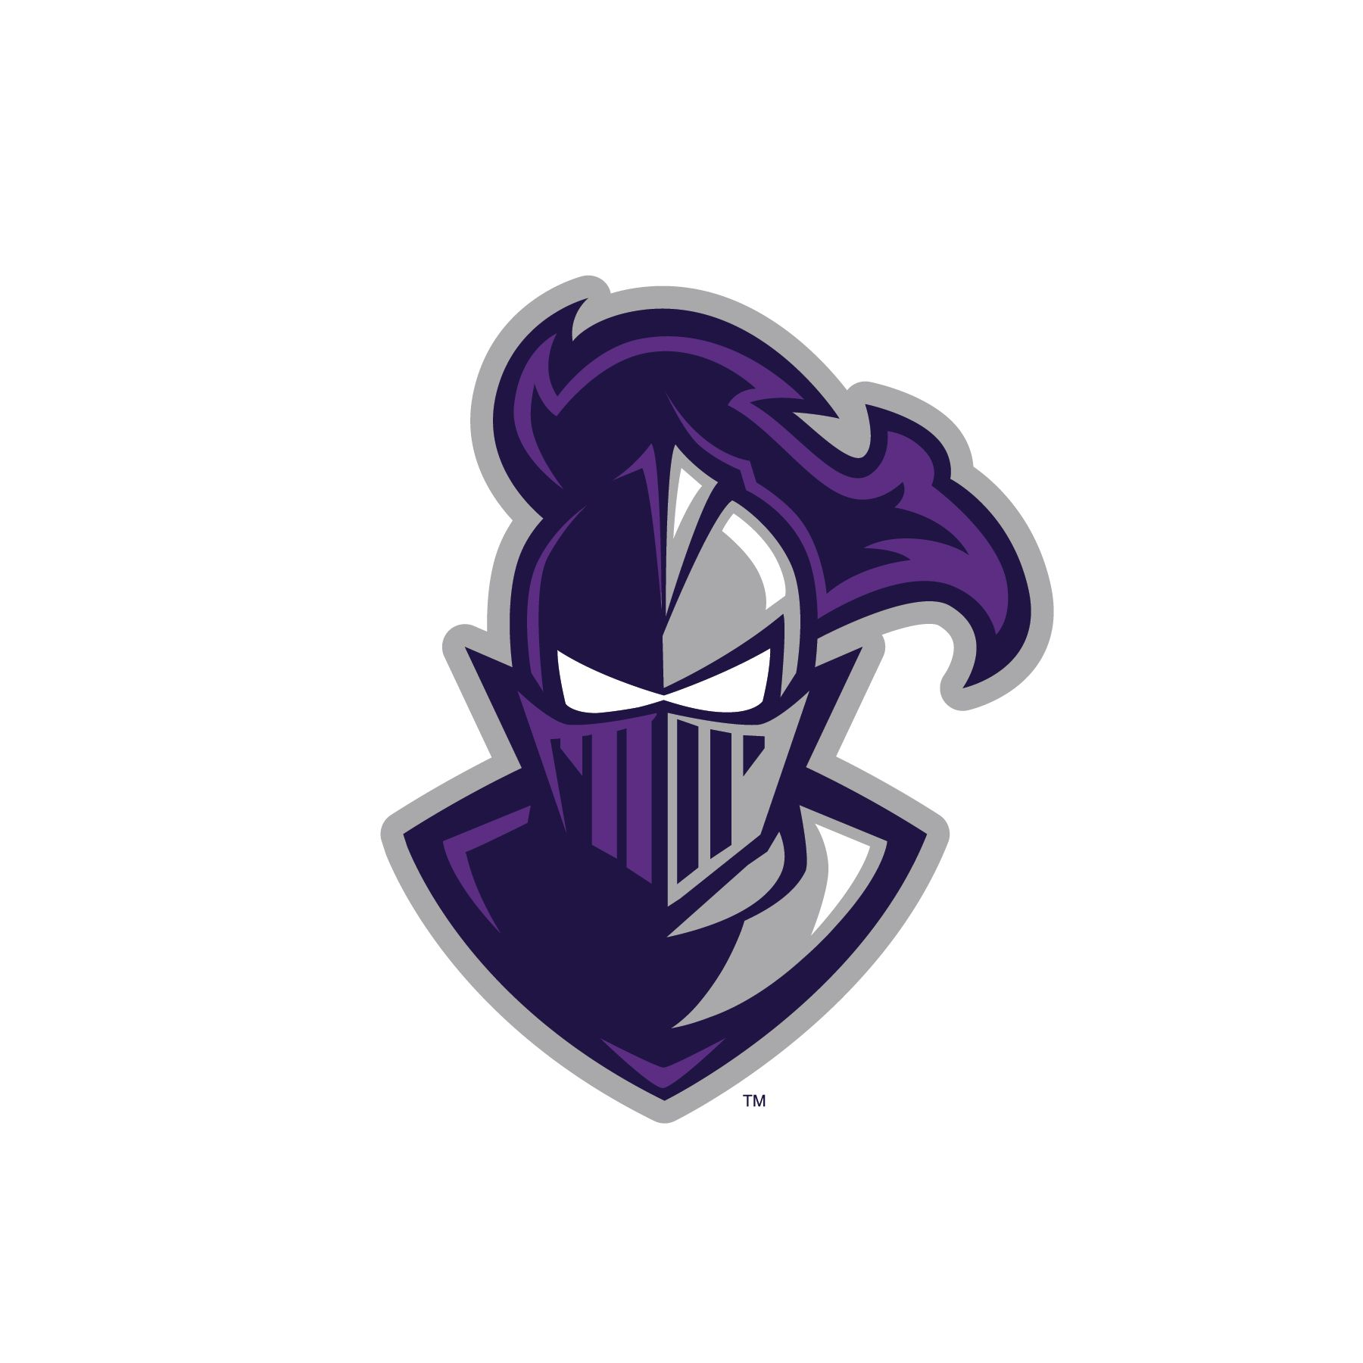
2026 Furman Cross Country Camp Schedule

Monday, June 29
2:30-3pm Check-In
3:30pm Welcome Meeting
4:00pm Performance Run/Practice
5:30pm Dinner
7:00pm Break Out into assigned groups (ice breakers & introductions)
9:00pm Camp Games
10:30pm Room Check

Tuesday, June 30
7:30-8:30am Breakfast
8:30-10:00am Main Training Session
12:00pm Lunch
2:00pm Guest Speakers
    - “Fueling for Performance”
    - “Mindset Matters”
4:00pm Second Training Session
5:30pm Dinner
7:00pm Camp Games
10:30pm Room Check

Wednesday, July 1
7:30-8:30am Breakfast
8:30-10:00am Main Training Session
12:00pm Lunch in dining hall
2:00pm Guest Speaker
- “Training tips from an Olympian”
- “Equipping the Elite Runner”
4:00pm Second training Session
6:00pm Dinner
7:30pm Lip Sync Competition
10:30pm Room Check

Thursday, July 2
7:30-8:30am Breakfast
8:30-9:30am Team Scavenger Hunt
9:30-10:30am Showers/Clean out room
10:30-11:30am Athlete Round Table Discussion + Awards Ceremony
12:00pm Check-out

